DTSC 671: AI Solutions in the Cloud

Speech-to-Text with Amazon Transcribe

Goal
Your organization wants to provide transcriptions for the videos that are created by its users. In this assignment, you will upload a short video file into an S3 bucket, which will trigger a Lambda function. The Lambda function will call the Amazon Transcribe API to convert the audio in the video to JSON file, which is then stored in a new S3 bucket. Another Lambda function is triggered and extracts the text in the JSON file and saves it in a TXT file, which is then placed in a new S3 bucket.

We want both a JSON file and a TXT file as the data science team has different interests and uses for the different file types.

Given the multiple steps in this architecture, a workflow orchestration service such as Amazon Step Functions would be recommended, but that service is beyond the scope of this course.

You will submit the template with the requested screenshots, along with the video, on Brightspace. Please note you only have one submission attempt.

Architectural Overview




Upload video file to S3 bucket
S3 upload triggers new Lambda function to extract text from JSON and save as TXT file
Lambda saves TXT file in different S3 bucket
S3 upload triggers Lambda function which uses Transcribe to convert video file to JSON file
Lambda saves JSON file in different S3 bucket


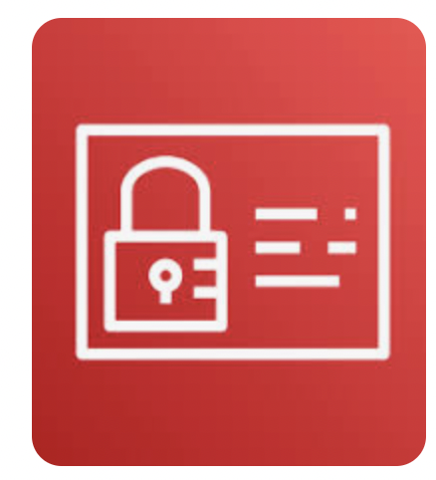
IAM role enables Lambda to create CloudWatch log to track activity
IAM role enables Lambda to create CloudWatch log to track activity
IAM role gives Lambda the permissions to retrieve and store files in S3
IAM role gives Lambda the permissions to retrieve and store files in S3 and call Transcribe API

Pricing Estimate
The following estimate shows the costs you may incur on your AWS personal account.

AWS Pricing Estimate
Service | Calculation | Cost
S3 Standard Storage | You will store an MP4 video file, a JSON file output and a TXT file output in 3 different buckets  - Suppose the MP4 file size estimate: 16 MB  - JSON estimate: 10 KB  - TXT estimate: 314 B  The total size is 16.010314 MB = 0.016010314 GB  S3 Standard pricing is roughly $0.023 per GB per month (varies slightly by region).  0.016010314 GB × $0.023/GB = $0.000368237222 per month | < $0.01
Lambda | First Lambda assumption:  - Memory allocated: 128 MB  - Execution time MP4-to-JSON: 550 ms (billed + initial)  - Requests: 1  - GB-seconds: (128 MB ÷ 1024) × 0.55 sec = 0.069 GB-sec  Second Lambda assumption:  - Memory allocated: 128 MB  - Execution time JSON-to-TXT: 90 ms (billed + initial)  - Requests: 1  - GB-seconds: (128 MB ÷ 1024) × 0.090 sec = 0.011 GB-sec  Lambda pricing:  - Free tier: 1M requests & 400,000 GB-seconds/month  Cost Calculation (if beyond free tier)  - Cost: (0.069+0.011) GB-second × $0.00001667 = $0.000001 | Free tier
Transcribe use in Lambda function | Transcribe pricing is $0.0004 per second of video, with a minimum charge of 15 seconds per request. If your account is in the first 12 months, you get a free 60 minutes of transcription per month.  Suppose you have a 20 second video (after the free tier):  - 20 seconds x $0.0004 per second = $0.008 | $≈$ $0.01

Directions
Make sure that all your services are in the same region (e.g., us-east-1)
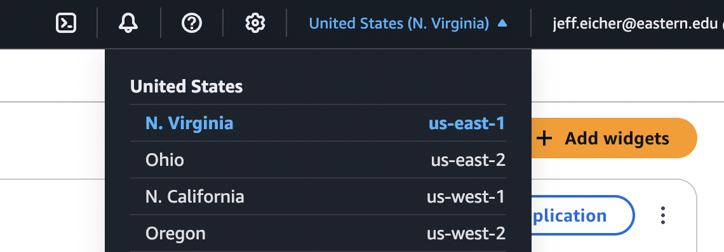

STEP 1: Create a short video (15 seconds or less) of yourself saying a few sentences.
- Create a short video of yourself saying a few sentences (15 seconds or less). Save the file as an MP4. You can use Zoom or another software to record your video. (It will be good practice for DTSC-690, which requires a video presentation!)

- Save the file locally as an MP4 file with a meaningful title (e.g., your name would work)

- Note: We will not load this MP4 into S3 until later in this assignment

STEP 2: Create three S3 buckets
- Name one bucket dtsc-671-transcribe-input-<term>-<year>-<name>
  - For example, dtsc-671-transcribe-input-fa1-2025-jeffeicher
  - Include tags for cost tracking; such as key: dtsc-671 value: transcribe
- Name one bucket dtsc-671-transcribe-output-json-<term>-<year>-<name>
  - For example, dtsc-671-transcribe-output-json-fa1-2025-jeffeicher
  - Include tags for cost tracking; such as key: dtsc-671 value: transcribe
- Name one bucket dtsc-671-transcribe-output-txt-<term>-<year>-<name>
  - For example, dtsc-671-transcribe-output-txt-fa1-2025-jeffeicher
  - Include tags for cost tracking; such as key: dtsc-671 value: transcribe
- Note: We are not loading anything in the S3 buckets at this point in the assignment

How do I make an S3 bucket?
Tutorial: How do I make an S3 bucket?

STEP 3A: Create Lambda function #1
- Create a Lambda function with the name: video-transcription-<name>
  - Use Runtime: Python 3.13
  - Example: video-transcription-jeffeicher
  - Include tags with the key-value pair as dtsc-671 and transcribe, respectively

How do I create a Lambda function?
Tutorial: How do I create a Lambda function?

SET 3B: Configure Permissions for Lambda function
The role must have basic lambda permissions (which includes CloudWatch logging), S3 access to both buckets, and calling the Amazon Transcribe API.

- The Lambda function needs permission to read files in the input S3 bucket and post files in the output S3 bucket. Select “Configuration,” then “Permissions.”
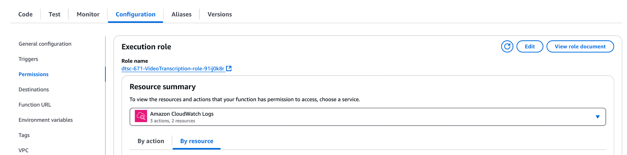

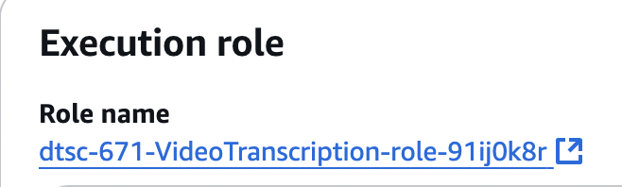
- Click the hyperlink with the Role name. Unlike the screenshot, your role name should be the name of your Lambda function, video-transcription-<name>, with random letters and numbers at the end. Selecting the role name will open an IAM window.

- Add permissions to this role, including the AWS managed policies AmazonTranscribeFullAccess and AmazonS3FullAccess. Note: In this assignment, we will use FullAccess permissions, which is not the best practice. Best practice would limit the actions and resources that Lambda can access, that is, follow “the principle of least privilege.”

How do I add permissions to an IAM role?

Tutorial: How do I add permissions to an IAM role?

SET 3C: Configure Lambda function #1
- Navigate back to the Lambda function you created above.
- In the diagram, select “+add trigger”. Find the S3 bucket you made earlier with “input” in the name. Have “All object create events” selected under “Event Types”. Include the file extension .mp4 as the optional suffix. This means that the Lambda function will not start if the file that lands in this input bucket does not have a suffix of .mp4
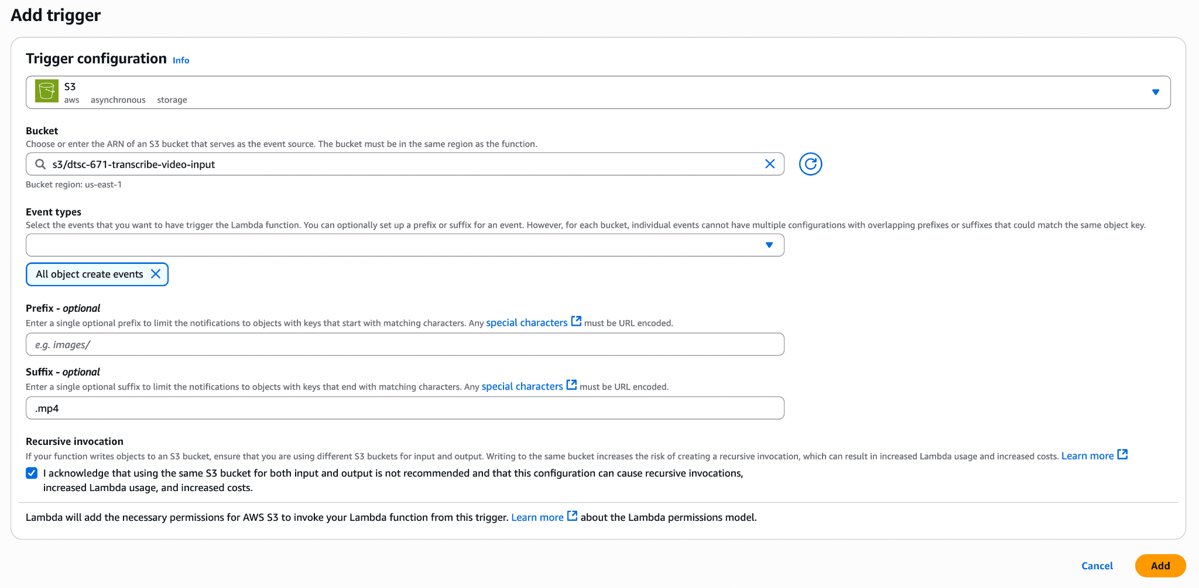

- In the diagram, “+add destination” as the “output-json” bucket you made earlier. Leave all other settings as the defaults. Select “Save.”
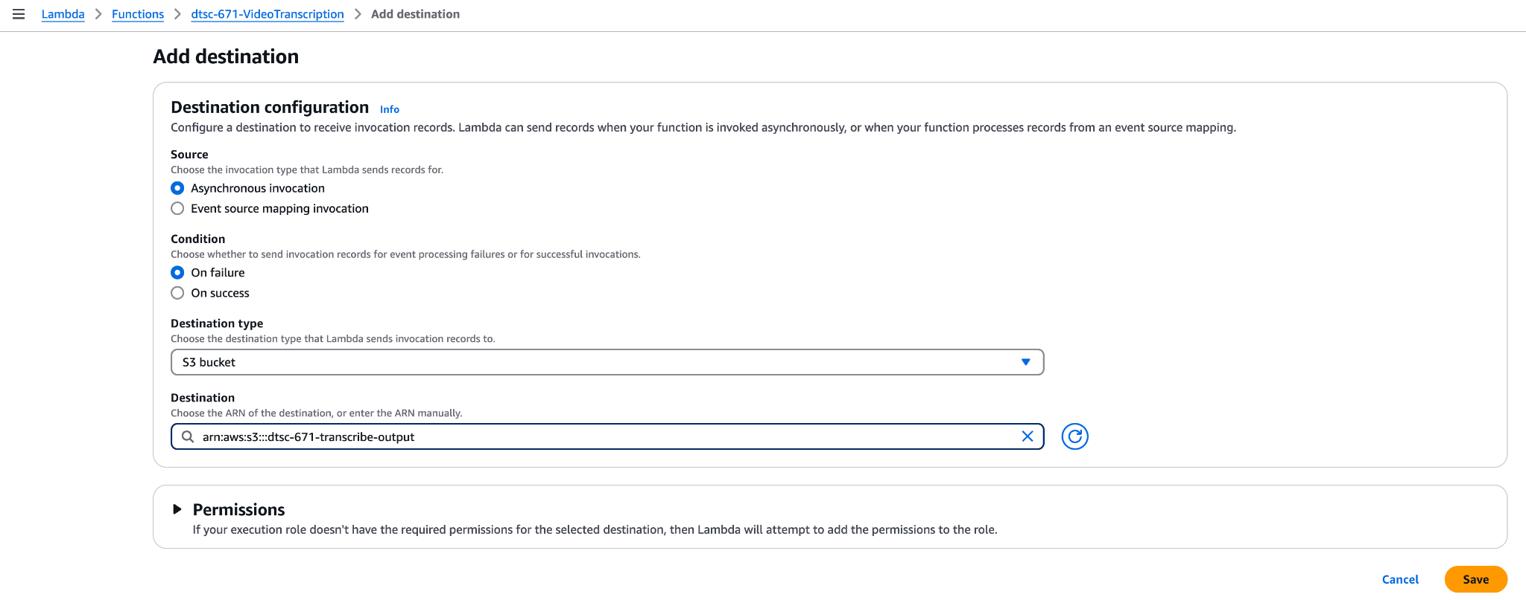
- You should now have this diagram (the name of the Lambda function will differ)
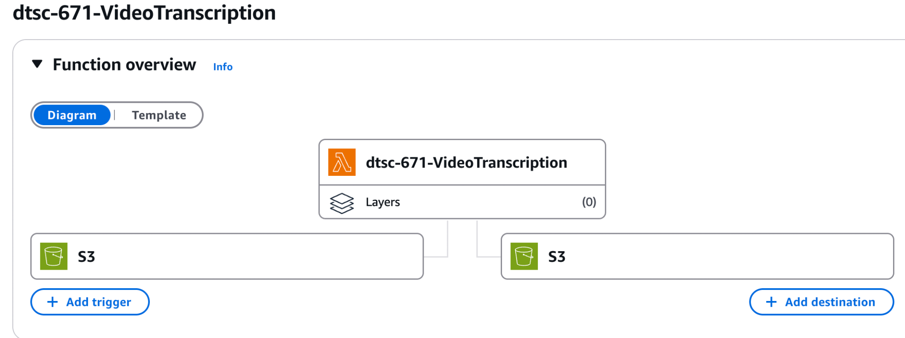

- Under the “Configuration” tab, select “General Configuration” on the left. Change the “Timeout” from 3 seconds to 1 minute. Everything else can remain the same. Select “Save”.

STEP 4: Write code for Lambda function #1 and deploy

How do I write Python code for a Lambda function to access objects in S3?
Tutorial: How do I write Python code for a Lambda function to access objects in S3?

Guidance and Tips
- We encourage you to use an LLM (like ChatGPT, Gemini, etc.) to help you write and debug the code for your Lambda function
  - We recommend not trying to have your Lambda function do “too much”. The reason we are not having the Lambda function to convert from MP4 to JSON to TXT is because it is a best practice to separate tasks and functions.
  - When writing prompts for an LLM, ask the LLM to include error handling to help you diagnose issues with your code or architecture.
  - Give the LLM information such as your Runtime (i.e. Python 3.9)
- Include print statements through your code to help troubleshoot.
- Make sure the title of the JSON matches the title of the original MP4 file (other than the extension changed from .mp4 to .json)
- In this assignment, you'll use the Amazon Transcribe API method start_transcription_job in your code. Here is the relevant documentation.
  - If you get a “transcribe subscription” error in your CloudWatch logs, read this article for assistance.
- Anytime you make edits to your code, be sure to hit “Deploy”; otherwise, your updated code will not run.
- Wait until the green banner shows the function has been deployed before moving on.

STEP 5 (Test Lambda #1): Upload your MP4 file to the input bucket
Although we plan to have two Lambda functions, let’s first test that your code works to convert the video to a JSON file.

- Once all the previous steps have been completed, upload the MP4 file of the video you created to the transcribe-input S3 bucket.

- Even if you’re not sure your code will work, you can upload the MP4 file and see what happens! As long as the video file isn’t large (<16 MB) the costs will be very minimal (i.e., <$0.001).

STEP 6: Was the 1st Lambda successful?
There are multiple ways to check if your Lambda function is correct.
- Check your S3 output-JSON bucket: Is there a JSON file there? If so, does it have a transcription of the video you created?

- You can go to the “Monitor” tab in your Lambda function, and select “View CloudWatch logs”
Note: If your IAM permissions are not set correctly, you will not see any cloudwatch logs for this lambda function.
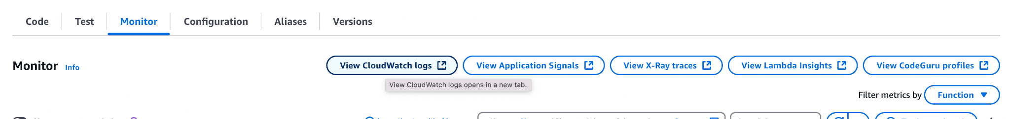

- In CloudWatch, you will see a new log each time you run the Lambda function.
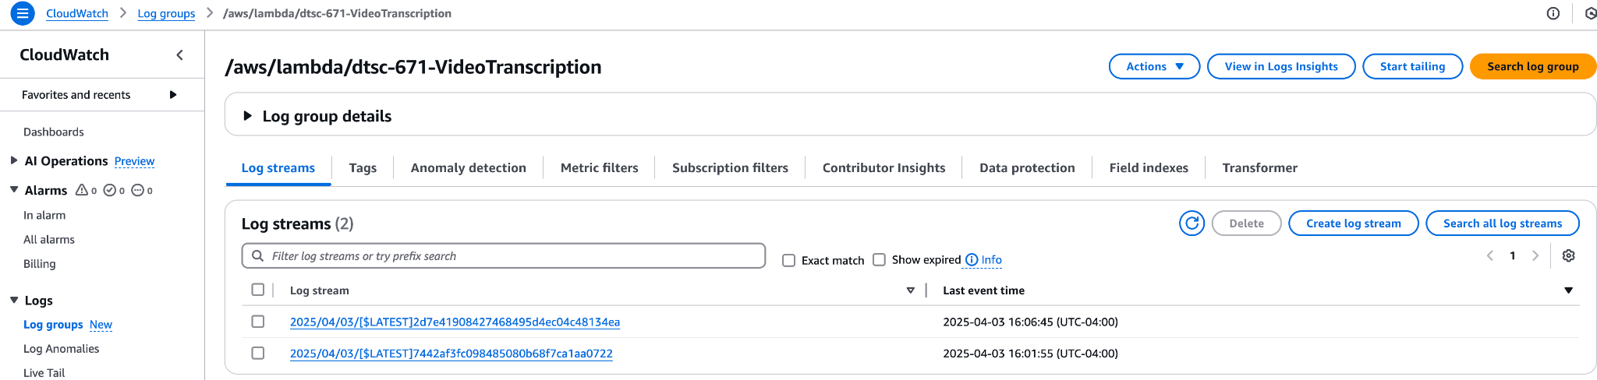

- Check the S3 output-JSON bucket. If the JSON file is there, download it and view it. It should have the transcription of your video. If not, your Lambda function code is not working as expected.

- If the function did not work as expected, see below for troubleshooting ideas

STEP 7: Troubleshoot, Part 1

- How do I use CloudWatch logs to troubleshoot my code and architecture?

- Use an LLM to troubleshoot
  - When writing prompts to develop your code, ask the LLM to include error handling to help you diagnose issues with your code or architecture.
  - Give the LLM information such as your Runtime (i.e. Python 3.9)
  - The LLM will likely give you a list of error possibilities. Work carefully through each one. If there’s still an error, let the LLM know what you did to fix any issues.
  - After you have tried troubleshooting with an LLM, if you email the GAs or professor, you must include screenshots of your architecture and error messages.

- Here are possible errors with the Amazon Transcribe method StartTranscriptionJob.

- Re-upload (or overwrite) your existing MP4 file in the S3 input bucket. This action will trigger the lambda function to run again. If it still does not produce a JSON with a transcription of your video, continue troubleshooting.

- What information does the professor or GA expect in order to assist you?
  - Helping you is much different than classes with CodeGrade—we can’t simply jump into your AWS account and troubleshoot!
  - We expect one or both of the following:
    - Screenshots of your architecture, following each step above, so we can find where the issue may be
    - A video showing your architecture, including the error messages in CloudWatch.
  - An email that says “my lambda function is not working” is not sufficient and is not helpful
  - Do not post your lambda function code on the discussion boards. All other information and questions can appear there.

STEP 8: Create, Configure, and Test Lambda #2
Before beginning this step, you need to have a functioning Lambda function that transcribes an MP4 and stores the result as a JSON file in an S3 bucket.

Repeat the steps above to create and configure a second Lambda function, which will extract the text from the JSON file and store the text as a TXT file in the output-TXT S3 bucket.
Creation Tips and Directions:
- Create a Lambda function with the name: json-to-txt-<name>
  - Example: json-to-text-jeffeicher
  - Include tags with the key-value pair as dtsc-671 and transcribe, respectively
- Use a new IAM role for this Lambda function; do not use the same role as the first Lambda function. Make sure the role contains CloudWatch logging and S3 access.

Configuration Tips:
- Make sure you understand which bucket will trigger your Lambda function and which bucket will store your results. Beware of recursive invocation!
- This Lambda function does not need access to the Amazon Transcribe API.

Code Tips:
- Utilize an LLM to help write and troubleshoot your code. Include print() statements and logging to assist in troubleshooting your code.

Testing Tips:

- When your code is ready for testing, download your JSON and reupload it to the output-JSON bucket. This should trigger your second Lambda function to convert the JSON to TXT.

STEP 9: Brightspace submission
- Download the assignment template with requested screenshots as a PDF document (File > Download > PDF Document). Submit your template PDF to the Brightspace assignment.
- Submit the original MP4 video file to the Brightspace assignment.

This is course material that was distributed to students enrolled in DTSC 671 at Eastern University. The materials were made exclusively available to students solely for the purpose of completing the course and are not intended for further distribution or retention beyond the course period. The materials were created by program faculty specifically for use in courses at Eastern University.

“I acknowledge that using the same S3 bucket for both input and output is not recommended and that this configuration can cause recursive invocations, increased Lambda usage, and increased costs” (emphasis added).

